Book1

Practical research on network attack and defense: Exploitation of vulnerabilities and empowerment

Published by Electronic Industry Press in 2018

624 pages. By Zhu Liehuang and Zhang Zijian



This book mainly discusses the current common vulnerability exploitation and empowerment technology, respectively from the point of view of attack and defense to introduce the penetration process is relatively difficult, but also the highest state of penetration - how to obtain the server and even the entire network permission. The book is divided into 9 chapters, from the simple to the deep, according to the reader's easy to understand the content of the classification, each section introduces a typical application, combined with cases to explain, and give some classic summary. The purpose of this book is to introduce vulnerability exploitation and empowerment techniques, combined with some cases to discuss network security, so as to stay away from the threat of hackers. Through the study of this book, readers can quickly understand and master the mainstream vulnerability exploitation and empowerment technology, and strengthen their own servers.

Book2

Database security

Published by Science Press in 2005

Authors ZHANG Min, XU Zhen, FENG Dengguo

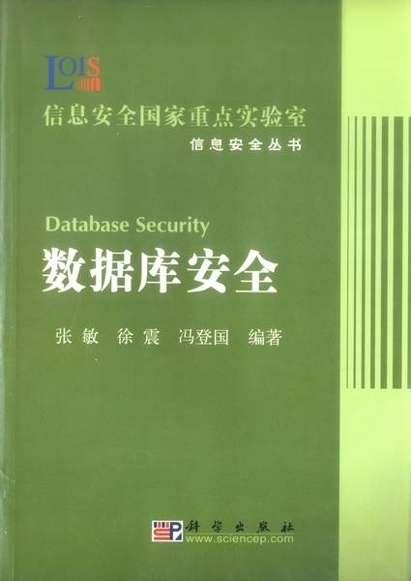

This book introduces the concept, background knowledge and security model of information security and database security. This paper introduces the basic principle, typical principle and implementation method of multilevel security database, as well as the evaluation and technical standards of database security at home and abroad.

Book3

mysql database technology and application

Published by Tsinghua University Press in 2021

The author is Zhao Mingyuan

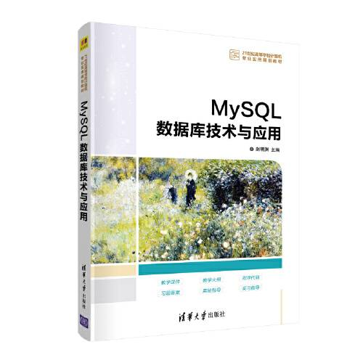

This book is based on the principle of database, with MySQL8.0 as the platform, and the student achievement database as the main line. The book has 17 chapters. This section introduces the database and MySQL Database system, database creation, table creation, table data manipulation, data query, view, index, data integrity, MySQL programming, functions and cursors, stored procedures and stored functions, triggers and events, transactions and locks, security management, backup and recovery, Big Data and cloud computing, PHP and MySQL student score management system development, etc. This course can be used as a teaching material for undergraduate, vocational and training courses, suitable for computer application personnel and computer enthusiasts.

Book4

Database security technology

Published by Industrial Press in 2019

Authors: Huang Shuiping and Ma Zhenchao



This book provides a comprehensive introduction to SQL Server database and MySQL database security related knowledge. There are six items in the book, including basic knowledge of SQL Server 2008, SQL Server 2008 security management, database maintenance, data encryption, MySQL database security basics and MySQL database advanced security maintenance. This book is project-driven, supplemented by the explanation of knowledge points, from simple to deep, step by step guide readers to learn and practice. This book can be used as a teaching material for network information security and related majors in various vocational colleges, and can also be used as a reference for database managers and computer enthusiasts.

Web1

<https://cn.aliyun.com/solution/security/datasecurity?from_alibabacloud=>

Web2

<https://www.ibm.com/cn-zh/topics/database-security>

Web3

<https://www.ibm.com/cn-zh/products/ibm-guardium-data-protection?utm_content=SRCWW&p1=Search&p4=43700077245040576&p5=1&gclid=CO7lvfLo7>

Web4

<https://zhuanlan.zhihu.com/p/54624891>